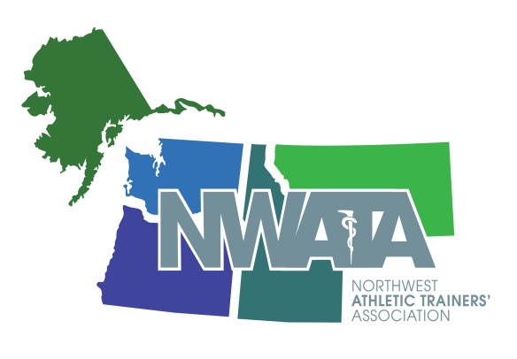

NWATA – Membership Meeting Agenda
Tuesday, June 25th - 5:30 PM
Las Vegas, NV – Mandalay Bay L

- Meeting Called to Order 5:30pm (183 in attendance) Tony

- Introduction of Guests Tony
First time attendees
Newly Certified
New to NWATA
NWATA/NATA HOF Members
Dennis Sealey
- Approval of March 2019 Meeting Minutes Tony
Motion – Chandra
2nd CJ Wright
- Honors and Awards Tony
  - Membership Longevity Recognition
  - Athletic Training Challenge – University of Montana
  - District Quiz Bowl - Boise State University
  - National Scholarship Recipients
- PFATS Steve “Greek” Antonopolous Scholarship - Katherine Berglund, University of Montana
- Richard E Vandervoort Memorial Scholarship - Hunter Lindsay, University of Montana
- Jim Whitesel Memorial AT Scholarship - McKayla McNamara – University of Montana
- District 10- Mark J Smaha Scholarship - Jennifer McCaw, Idaho State University
  - 2019 National Award Recipients
- ATSA - Shelly Jones
- YP Award of Distinction Kaleb Birney
- 2019 Best Case Study - Tayleigh Talmadge, University of Montana
- 2019 Best Literature Review - Olivia Fellers, University of Montana
  - New CAATE Commissioner – Forrest Pecha
- Secretary Report - Ben
  - Membership Update - 1832 members, continues to increase.
  - “Project 2000” – Will be the discussion for the NWATA BOD meeting in July. Considering changes to structure and resources provided as we grow to 2000 members. We will need to consider expenses and operations for a “larger” district. These changes will also include a member benefits push to get us to 2000 members. Discussed connecting with ATEP directors to increase student membership category. Going to lean on the committees to help us achieve this objective.

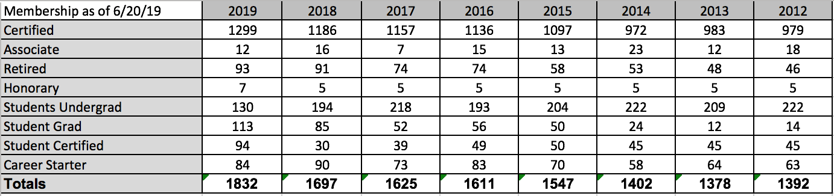

- Treasurer Report - Craig
- Treasurer’s Report – NWATA came in $10k under budget for the NWATA Annual Meeting. Focusing on fine-tuning certain line items based on specific costs for each site held. The size of our meetings significantly effects our revenue (150 participants increased revenue by $15K in 2018). In 2018-19 we were able to draw $1500 from the Raymond James investment account and $1000 from the Umpqua investment account to go toward our $8000 in scholarships that we give out. This table reflects these transactions. This accounting also reflects the actual checking account figures after most payments have been made and accounted for following the NWATA Annual Meeting and Clinical Symposium held in Spokane in March 2019. We are consistently working on ways to improve on the benefits and services provided to members at the annual meeting and throughout the year at the same time being as fiscally responsible as possible.

 | June 25, 2019 | March 30, 2019 | June 27, 2018 | March 22, 2018
Checking | $92,261.62 | $159,961.54 | $86,736.35 | $153,251.88
Savings | $28,031.84 | $28,026.90 | $28,012.23 | $28,007.29
Raymond James | $34,998.57 | $35,265.05 | $36,435.44 | $35,633.62
Umpqua | $28,013.94 | $27,908.00 | $28,637.51 | $27,918.57
NET WORTH | $183,305.97 | $253,661.49 | $179,821.53 | $244,811.36

- Director’s Report Tony
NATA News
- NATM Generated over 250 Articles
- Sports Medicine Legal Digest is contracting with a journalist
- NATA, NFL and KSI are collaborating to rebrand and relaunch “Raise the Rank”. The focus will be on the “WHY” and not ranking
- Approved funding for a 3 Year Partnership with Sidelined USA.
  - This organization is designed to assist athletes who become medically disqualified for participation in sports for various reasons
- YPs are releasing a Best Practices document for per diem work
- Dr. Hainline from the NCAA informed the the NATA BOD that the NCAA Board of Governors endorsed guidelines for Catastrophic Injury
  - Addressed “Punishment Practices/Conditioning
  - Recommendations for Strength Coaches to report to medical administrator
- Updated the NATA Liaison program
  - Assigning new responsibilities to our NATA Liaisons based on how the relationship fits within the NATA Strategic Plan, Projects, Education, Legislation
  - Continuing to Evolve
- 3rd Party Reimbursement Project
  - More states are becoming actively involved
    - Idaho and Oregon were two of the top active states
  - Prioritizing Payor Advocacy Strategy and Efforts
  - Promote States being more Proactive
- ACO Project
  - Missouri State University / Mercy Health Systems
  - Finalizing Contract
  - Goal to begin collecting data on treating the Medicare Patient July 1
- ESPN OTL did a segment today at 1pm EST regarding the ICSM Independent Medical Model Survey
  - Discussion points regarding Independent Care, Pressure, etc
- Member Directory
  - Now housed in gATher
  - You can communicate with any NATA Member
  - Protects your personal contact information
  - YOU as a member need to OPT IN
- RFP for Per Diem Employment Company
  - Member Benefit
  - Only One Company Applied
  - Go4Ellis
- District 4 Split
- Future Meetings
  - 2020 – Atlanta
  - 2021 – Orlando
  - 2022 – Philadelphia
  - 2023 – Indianapolis

NWATA News Tony
- Created a New NWATA Award - Recognizes a members contributions to elevating our profession Nationally, District, State or Local Level(s) Named NWATA ElevATe
- Renamed NWATA Outstanding Service to District 10 Service - Recognizes a member(s) who have furthered the advancement of the NWATA
- Retooled the NWATA New Horizon Award, Aligns up with the new YP criteria. Looks at a YP’s service to the NWATA AND/OR to the Profession.
- Directed our Meetings team to look outside the present time frame for Spokane - Volleyball Tournament Issues
- Election Notification
  - Vote of Affirmation for District Director
  - Elect a new NWATA Secretary - Nominations accepted for Secretary - LOI and Vitae from July 29 to August 29, 2019, Balloting will run from September 9 – 30, 2019

- District Meeting Update Tony
  - 2019 Recap -
  - 2020 Boise - March 12-15, 2020 – Boise, ID
    - Boise Grove Hotel
    - Boise Convention Center
  - Local Coordinator: Joanna Schisel & Michele Loftis

- Committee Announcements
  - International Committee, Cynthia Wright– Resources available on the International Committee website. World conferences – Travel grants available, please apply.
  - ATs Care, Lisa Kenney - Please stop by the booth. Hosting crisis training in Tacoma on August 10th, 2019. 3-year review of program will be posted.
  - EAC, Gen Ludwig – Applications will come out this fall for EAC grants, looking for information about how the EAC can help the NATA membership – surveys will be sent out.
  - Governmental Affairs, Lynne Young – GA grants will open July 1st. Dan Campbell award was presented to Oregon for outstanding efforts in legislative efforts.
  - ICSM, Anna Taylor – Transition to practice resources and mental health toolkits are in the works.
  - Public Relations, Kaleb Birney – PR Grant is available. Please send in stories for the NATA News.
  - Ethnic Diversity, Grant Wilson – Grants available, more information on the Ethnic Diversity NATA site

- NATA Foundation Report Bill Drake
  - Congratulations to our student scholarship recipients (from up above)
  - NATA Foundation Events – Cornhole at NWATA Annual Meeting. NATA Events: Las Vegas Libations, NATA yoga event, Donate a Photo (J&J app)
  - NATA Foundation Jimmy Whitesel Scholarship - $18k away from the goal of $50k
  - Thank you to Val Moody for all of her NATA Foundation Work as she wraps up her time on the board

- NATAPAC Dana Gunter
- NATAPAC Breakfast – Ronnie Barnes was the keynote speakers. Best attendance in history, excellent D10 representation. Thank you to those who attended and sponsored students.
- Please visit the NATAPAC booth

- State Presidents Reports
  - Alaska - Lynne Young - Second annual safety in hockey campaign - increase in participation offering a bigger footprint for information to be presented. Launched both a Twitter/Facebook and facility challenge to our AT colleagues across the US. Movement toward decreasing AK ATs licensure fees from 500$/every 2 years to 100$/every 2 years. We had our annual meeting April 28th. ATs from Anchorage, Palmer, and Fairbanks were present. In addition we had members join via phone.
  - Idaho – Joanna Schisel - Working to update association bylaws and this next year create a policy and procedure manual. Monthly BOD calls and really starting to align across the state with IATA goals and initiatives. IATA Summer Symposium will be July 20th 2019 at College of Southern Idaho single day conference offering 6 CEUs. Next year’s IATA Summer Symposium will be July 24th-25th in Boise. 2nd Annual Hit the Hill Day will be March 11th 2020 and the IATA will be presenting to the Health and Welfare committee for House of Reps.
  - Montana – Paul Capp: MTATA State Meeting was June 7th and 8th, Splitting Secretary/Treasurer Position: Treasurer will monitor finances, look into savings account &/or investment options. Secretary will play a large role in fundraising and gaining sponsorships. Call for nominations will occur following 30 days of bylaws being posted publically (late July/early August). Policy and Procedures manual developed. Awards: Hall of Fame - Chris Heard (Butte, MT), JC Weida (Missoula, MT). Inaugural Young Professionals Award - Dustin Burton (Missoula, MT)
  - Oregon – Heather Halseth- Website Project – Professional design and management. Looking into a Financial Advisor for the association. SB 742 Was signed. Licensure will start January 2020. We are currently on probation. The Approved Provider requirements are lengthy and tedious. It could really be a full time job. Openings (Investment, CE, secondary schools, COPA, Honors & Awards).
  - Washington - Jen Carrol - BOC: We have run into issues with the BOC and we were notified in the spring about the loss of our BOC status. There are concerns about the challenges states are having in getting their BOC status and maintaining it. We are currently in the process of applying for our approved provider status again. Legislation: ESSB 5688 was signed on May 9, 2019. This legislations strengthens our title protection, adds pharmacology language, adds the administration of Epi-pens, adds suicide prevention training, amongst a few other changes and modernizations. The gains we made put us on a more even playing field with the other health care providers in the state. We will need to go back and work on definitions in the future. State Meeting: July 20, 2019 at Husky Stadium. We have great meeting planned. Website: we will be switching web masters in the coming weeks. KSI: We will be hosting a collaborative solutions meeting in Seattle September 11-12, 2019.

- Old Business

- New Business

- Other

- Adjourn – 6:32pm

See you in Boise!

